Resizable Concurrent Hash Tables - Final Project
Graduate Student,
BU MET collage Computer Science Department,
CS566 – Dr. Alexander Belyaev
Fall 2017

Table of Contents
Abstract 3
Introduction 3
Hash Table 4
Collision Resolution 5
Resizing Hash Table 7
Concurrency Level and Segments 8
Implementation 9
Performance Evaluation 12
Prototype Source Code 14
Conclusion 21
Glossary 22
References and Links 22

Abstract
Hash table is an efficient and widely used data structure in modern implementation. Nowadays, concurrent structures and systems are inevitable so, the understanding of the hash table is a great value. The main aim is to understand and implement the concurrent hash table. There are some design goals in the designing the algorithm for hash tables. Implementation should be resizable and concurrent. This would be an efficient way to understand theory of concurrent hash tables and see the relation between the theory and the practice. This research shows that algorithm is significantly fast and efficient.

Introduction
Parallel structures have begun to appear as models for the solution of current problems in recent years. Concurrent programming techniques are that multiple threads can access a shared resource such as data structures. Parallel systems are used to increase performance and enhance capacity. This study examines the implementation details of concurrent hash table applications.
Concurrent hash tables are one of the most important concurrent data structures with several examples. As an example, a total of 32767 operations in the LINUX operating system can work at the same time.
Some functions take a number called process id and access the process table. When a process id is given, a hash table is typically used to obtain the address of the process table.
Or, another example, the buffer cache mechanism in LINUX uses hash tables to detect whether a disk block is in cash. In that time, there may be hundreds of disk blocks in Cache. When a block read is requested, it will be checked whether the block is in cash. Here, a hash table is used instead of examining the blocks in the cache one by one. High-performance systems in the hash table then there's a very large significance.
This project is a study of how the resizable concurrent hash table data structure is implemented in multithreaded environment which efficient synchronization is essential in concurrent accesses and the analysis of this data structure. In the implementation details, concurrent hash tables require some synchronization. By synchronous means that it allows concurrent threads to read or write the value from same hash table in the same time. So, this data structure improves performance. This paper, details of resizable concurrent hash table algorithm will be defined.
Concurrent hash table implementation in this research describes based on open addressing and linear probing to be placed with the index obtained by hash functions and it is also supports resizing which supports dynamic size adaptation, deleting entries, and templated key/value types.
Last section discusses the detail of our implementation of resizable concurrent hash table and analyzes the results.

Hash Table
A hash table is a data structure which implements an associative array abstract data type, a structure that can map keys and values. A hash table uses a hush function to compute an index into array of buckets or slots, from which the desired value can be found.
Ideally, the hash function will assign each key to a unique bucket, but most hash table designs employ an imperfect hash function, which might cause hash collisions where the hash function generates the same index for more than one key. Such collisions must be accommodated in some way.

Collision Resolution
Hash collisions are practically unavoidable when hashing a random subset of a large set of possible keys. For example, if 2,450 keys are hashed into a million buckets, even with a perfectly uniform random distribution, according to the birthday problem there is approximately a 95% chance of at least two of the keys being hashed to the same slot.
Therefore, almost all hash table implementations have some collision resolution strategy to handle such events. Some common strategies are described below. All these methods require that the keys (or pointers to them) be stored in the table, together with the associated values.
Separate chaining — in the method known as separate chaining, each bucket is independent, and has some sort of list of entries with the same index. The time for hash table operations is the time to find the bucket (which is constant) plus time for the list operation.
In a good hash table, each bucket has zero one entries, and sometimes two or three, but rarely more than that. Therefore, structures that are efficient in time and space for these cases are preferred. Structures that are efficient for a fairly large number of entries per bucket are not needed or desirable. If these cases happen often, the hashing function needs to be fixed.
Chained hash tables with linked lists are popular because they require only basic data structures with simple algorithms, and can use simple hash functions that are unsuitable for other methods.
The cost of a table operation is that of scanning the entries of the selected bucket for the desired key. If the distribution of keys is sufficiently uniform, the average cost of a lookup depends only on the average number of keys per bucket —that is, it is roughly proportional to the load factor.

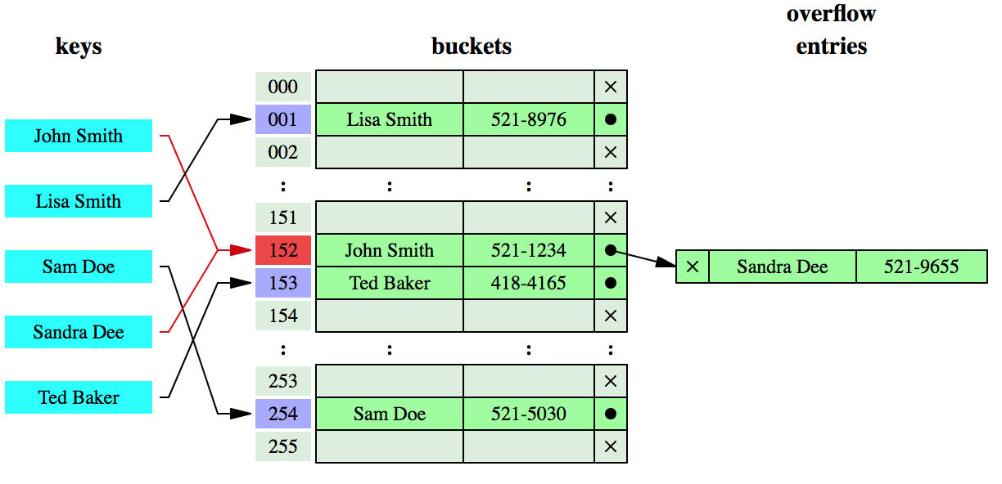
Figure 1.
In another strategy, called open addressing, all entry records are stored in the bucket array itself. When a new entry has to be inserted, the buckets are examined, starting with the hashed-to slot and proceeding in some probe sequence, until an unoccupied slot is found. When searching for an entry, the buckets are scanned in the same sequence, until either the target record is found, or an unused array slot is found, which indicates that there is no such key in the table. The name “open addressing” refers to the fact that the location (“address”) of the item is not determined by its hash value.
Well-known probe sequences include:
Linear probing, in which the interval between probes is fixed.
Quadratic probing, in which the interval between probes is increased by adding the successive outputs of a quadratic polynomial to the starting value given by the original hash computation.
Double hashing, in which the interval between probes is computed by a second hash function.
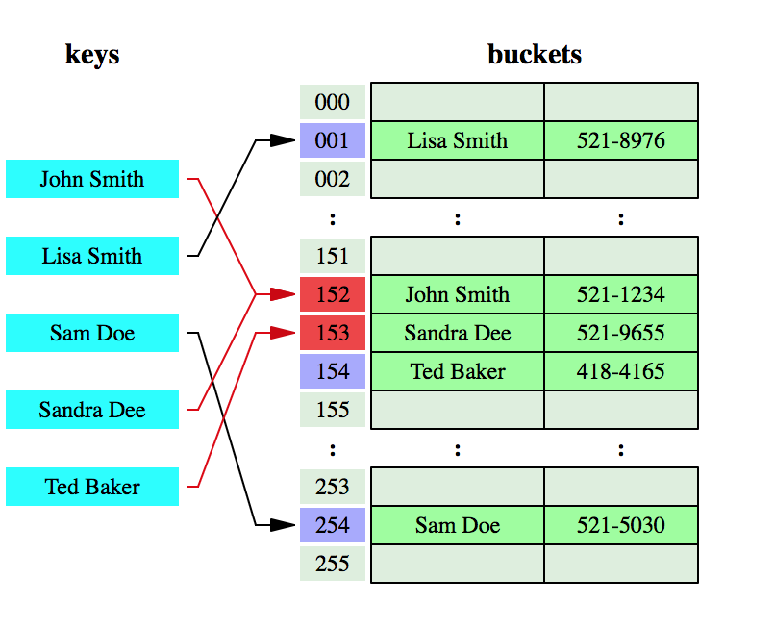

Figure 2.

Resizing Hash Map
While creating a hash table, one of our goals is to create it in a balanced way. So creating a very large size array from the beginning will cause the cost in terms of search time. The number of elements which is adding to hash table will constantly increase even if it is perfectly balanced. As a result, the either adding elements should be stopped or the size of the array should be increased dynamically. The solution is load factor which keep tracking the number of elements in the hash table.
If the load factor ratio which calculated and number of entries on hash table and table size reaches the threshold, the hash table must be resize and it should increase its capacity.
Resizing process is as follows:
- Assign table size to twice the original size.
- Calculate new load factor with new length of table.
- Create a new table which has twice length from old table size.
- Put elements in the old table to the new table with calculating hash. Hash values is dependent with length of table. So, hash values have to be calculated for all key-value pairs in the old table.
Suppose the hash function h1 (x) = x% 5 is used. When resize() method is applied, new hash function will be h2 (x) = x% 10 and table size will be twice the old table. Figure 2 shows an example of resizing.

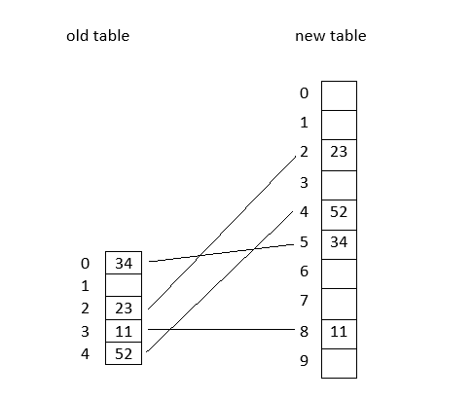
Figure 3. Insert (2, 23), (4, 52), (15, 34), (18, 11) pairs to old table and then it resizes automatically when reach limit.
Resizing process takes 0(n) time if n is a number of entries in the table. This does not impact complexity of other operations on hash table, however it could be problem in real time applications.

Concurrency Level and Segments
Concurrency refers to the ability of different parts of program, code or algorithm can be executed in partial order without affecting the final outcome. This can allow us for parallel execution of program which leads to a significant increase of speed of the processor.
Concurrency in the hash map allows to access elements in it by multiple threads concurrently without blocking an entire hash table. It can provide an ability to check if an element contains or get some value simultaneously unless you adding or updating the map.
To implement the concurrent hash map, we need to create an array type of Segment which can act as each thread can work on each segment during high concurrency.
By defining Segment class inside the concurrent hash map class, we initialize array size of 32.
protected static final class Segment{
protected int count;
protected synchronized int getCount() { return this.count; }
protected synchronized void synch() {}
}
public Segment[] segments = new Segment[DEFAULT_SEGMENT_SIZE];

Most important thing to understand the put method of ConcurrentHashMap, that how ConcurrentHashMap works when we are adding the element. As we know put method takes two arguments both of type Object as below:
put(Object key, Object value)
So it will 1st calculate the hash of key as below:
public int hash(int key)
{
return (key % table.length);
}

After getting the hash we can decide the Segment as below:
Segment seg = segments[(hash & 0x1F)];
Since it's all about concurrency, we need synchronized block on the above Segment as below:
@Override
public Integer put(Integer key, Integer value) {
if (key <0)
throw new IllegalArgumentException("Key Cannot be negative");
int hash = hash(key);
int indexOfDeletedEntry = -1;
Segment seg=segments[(hash & 0x1F)];
synchronized (seg){
if (size >= maxSize)
{
resize();
System.out.println("resizing finish ");
}
while ( (table[hash] instanceof DeletedEntry) || table[hash] != null && table[hash].getKey() != key)
{
if (table[hash] instanceof DeletedEntry)
indexOfDeletedEntry = hash;
hash = (hash + 1) % table.length;
}
if (table[hash] == null && indexOfDeletedEntry != -1)
{
table[indexOfDeletedEntry] = new HashEntry(key, value);
size++;
return table[indexOfDeletedEntry].getKey();
}
else if (!(table[hash] instanceof DeletedEntry) && table[hash] != null && table[hash].getKey() == key)
{
table[hash].setValue(value);
return table[hash].getKey();
}
else
{
table[hash] = new HashEntry(key, value);
size++;
return table[hash].getKey();
}
}
}

Implementation
This research is intended to show the implementation of the concurrent hash table data structure in detail. The design and implementation of concurrent algorithms correctly is quite difficult. ResizableConcurrentHashMap is an extension of the ConcurrentMap interface which was introduced as a part of the Java collections framework.
The basic important and essential functional methods through overriding several interface default methods are as follows:
put method(): This method is assigned the given key and given value by performing key-value matching according to the hash. Next step after getting hash is that segment is determined and synchronized block on this segment for provide concurrency.
Firstly, if the entry which is found by hash value is not null or deleted and given key is not present in this entries, then linear probing method is applied and hash value is incremented until find free place as below;
while ( (table[hash] instanceof DeletedEntry) || table[hash] != null
&& table[hash].getKey() != key)
{
if (table[hash] instanceof DeletedEntry)
indexOfDeletedEntry = hash;
hash = (hash + 1) % table.length;
}
In this case, the entry corresponds to a deleted entry, we keep the location of the deleted entry in order to use it later.
After that, there are 3 different situations in this method.
- If there is a deleted item in the appropriate hash, a new entry is created with the key and value given instead of the deleted item.
- If the finding hash does not belongs to the hash table, the given key and the given value will assign this hash with generating a new entry.
- Another situation is that if finding hash value is not null and given key is present in this entries, then this value is assigned to this entry with same key.
if (table[hash] == null && indexOfDeletedEntry != -1)
{
table[indexOfDeletedEntry] = new HashEntry(key, value);
size++;
return table[indexOfDeletedEntry].getKey();
}
else if (!(table[hash] instanceof DeletedEntry) && table[hash] != null
&& table[hash].getKey() == key)
{
table[hash].setValue(value);
return table[hash].getKey();
}
else
{
table[hash] = new HashEntry(key, value);
size++;
return table[hash].getKey();
}

get method(): When a thread calls this method, it returns the value that the given key belongs. If there is no entry that has a key, the method returns -1. This method also synchronized through segment for concurrency.
get() method synchronized block on the segment as below;
synchronized (seg) {
while ((table[hash] instanceof DeletedEntry || table[hash] != null) && table[hash].getKey() != key)
hash = (hash + 1) % table.length;
if (table[hash] == null )
return -1;
else
return table[hash].getValue();

}
resize method(): When a thread calls put() methods and the load factor which calculated with table size and number of entries on hash table reaches threshold, this function calls automatically.

loadFactor = numberOfEntry/table.length;

if (getLoadFactor() > threshold)
resize();

resize() method basically replaced with a new table with twice the size as below;
int tableSize = 2 * table.length;
HashEntry[] oldTable = table;
table = new HashEntry[tableSize];
for (int i = 0; i < oldTable.length; i++)
{
if (oldTable[i] != null && !(oldTable[i] instanceof DeletedEntry) )
put(oldTable[i].getKey(), oldTable[i].getValue());
}

remove method(): If there is an entry corresponding to the specified key, hash and segment are calculated and synchronized block on this segment for provide concurrency, and then it deletes. It means basically that deleted entry turns a "deleted item" as below;
table[hash] = new DeletedEntry();

Performance Evaluation
We test our implementation to see the performance result. In testing class, object which belongs to concurrent hash map is created. For testing concurrency, test class uses newFixedThreadPool(int n)method from Executors utility class. Thread pool keeps a lot of idle threads that are ready for short-lived executing tasks as needed.
ExecutorService threadPool = Executors.newFixedThreadPool(numThreads);

We create an executor with a pool of maximum 100 concurrent threads and we set up our concurrency level to 60.
final int CONCURRENCY_LEVEL = 60;
Keys and values are generated randomly and put, get and remove tasks are submitted with these keys and values to the pool. System.currentTimeMillis() which returns time elapsed in millliseconds is used for calculating running time.

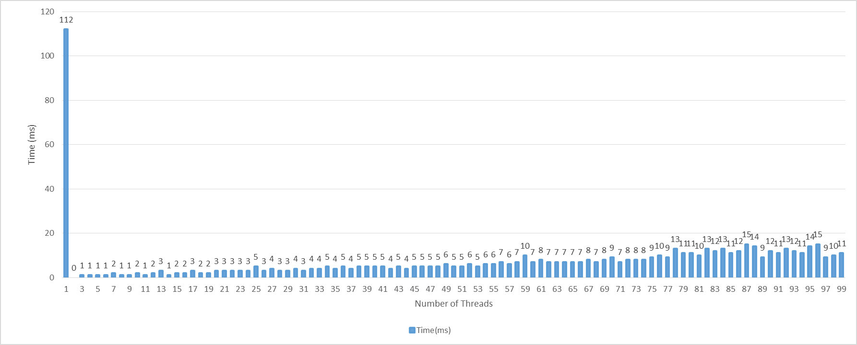
double throughput = (double)(numThreads * ITERATIONS ) / (double) totalMillis

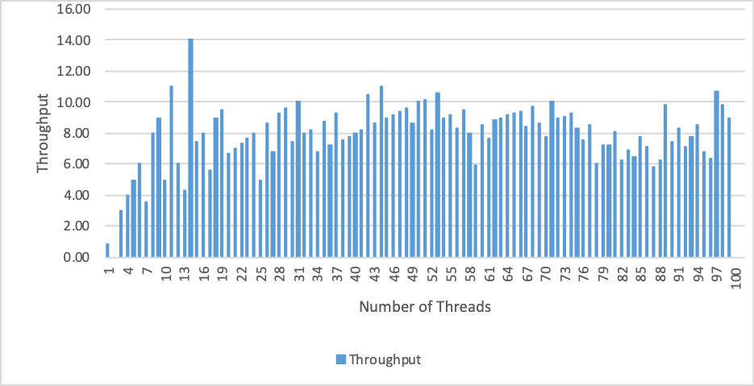

As a result of test, ResizableConcurrentHashMap has a worse performance when using with single thread, but adding more threads like concurrency level for work will definitely speed-up the process.

Prototype Source Code
Using the ConcurrentMap ConcurrentMap interface of the Java collections framework, code was created for a simple console application. Java was used in the source code of this document.
// ResizableConcurrentHashMap.java //

import java.util.Collection;
import java.util.Map;
import java.util.Set;
import java.util.concurrent.ConcurrentMap;

public class ResizableConcurrentHashMap implements ConcurrentMap<Integer, Integer>
{
static int count = 0;
protected final int CONCURRENCY_LEVEL = 16;
private float threshold = 0.75f;
protected int loadFactor = 0;
private int numberOfEntry = 0;

protected static final class Segment {

protected int count;
protected synchronized int getCount() {
return this.count;
}
protected synchronized void synch() {}
}

public Segment[] segments = new Segment[CONCURRENCY_LEVEL];
HashEntry[] table;

HashMap( )
{
table = new HashEntry[CONCURRENCY_LEVEL];
for (int i = 0; i < CONCURRENCY_LEVEL; i++)
table[i] = null;

for(int i=0; i<segments.length; i++){
segments[i]=new Segment();
}
}

public int getLoadFactor()
{
return loadFactor = numberOfEntry/table.length;
}

public int hash(int key)
{
return (key % table.length);
}

private void resize()
{
int tableSize = 2 * table.length;
loadFactor = (int) (tableSize * threshold);
HashEntry[] oldTable = table;
table = new HashEntry[tableSize];
numberOfEntry = 0;
if(segments.length< tableSize){
segments = new Segment[tableSize];
for(int i=0; i<segments.length; i++){
segments[i]=new Segment();
}
}
for (int i = 0; i < oldTable.length; i++)
{
if (oldTable[i] != null && !(oldTable[i] instanceof DeletedEntry) )
put(oldTable[i].getKey(), oldTable[i].getValue());
}

}

@Override
public int size() {

return table.length;
}

@Override
public boolean isEmpty() {

return (table.length==0)?true:false;
}

@Override
public boolean containsKey(Object key1) {
int key=(int) key1;
int hash = hash(key);
while ((table[hash] instanceof DeletedEntry || table[hash] != null) && table[hash].getKey() != key)
{
hash = (hash + 1) % table.length;
}
if (table[hash] == null )
return false;
else
return true;
}

@Override
public boolean containsValue(Object value) {
int val=(int) value;
for (int i=0; i<table.length; i++){
if (table[i].getValue()==val) return true;
}
return false;
}

@Override
public Integer get(Object key1) {
int key=(int) key1;
int hash = hash(key);
Segment seg=segments[hash];
synchronized (seg) {
while ((table[hash] instanceof DeletedEntry || table[hash] != null) && table[hash].getKey() != key)
{
hash = (hash + 1) % table.length;
}
if (table[hash] == null )
return -1;
else
{
return table[hash].getValue();
}
}
}

@Override
public Integer put(Integer key, Integer value) {
if (key <0)
throw new IllegalArgumentException("Key Cannot be negatif");
int hash = hash(key);
int indexOfDeletedEntry = -1;
Segment seg=segments[hash];
synchronized (seg){
if (getLoadFactor() > threshold)
resize();
while ( (table[hash] instanceof DeletedEntry) || table[hash] != null && table[hash].getKey() != key)
{
if (table[hash] instanceof DeletedEntry)
indexOfDeletedEntry = hash;
hash = (hash + 1) % table.length;
}
if (table[hash] == null && indexOfDeletedEntry != -1)
{
table[indexOfDeletedEntry] = new HashEntry(key, value);
numberOfEntry++;
return table[indexOfDeletedEntry].getKey();
}
else if (!(table[hash] instanceof DeletedEntry) && table[hash] != null && table[hash].getKey() == key)
{

table[hash].setValue(value);
return table[hash].getKey();
}
else
{
table[hash] = new HashEntry(key, value);
numberOfEntry++;
return table[hash].getKey();
}
}
}

@Override
public Integer remove(Object key1) {
int key =(int) key1;
int hash = hash(key);
Segment seg=segments[hash];
synchronized (seg) {
while ((table[hash] instanceof DeletedEntry) || table[hash] != null && table[hash].getKey() != key) {
hash = (hash + 1) % table.length;
}
if (table[hash] != null) {
int removing_value = table[hash].getValue();
table[hash] = new DeletedEntry();
numberOfEntry--;
return removing_value;
}
return null;
}

}
Test Case:
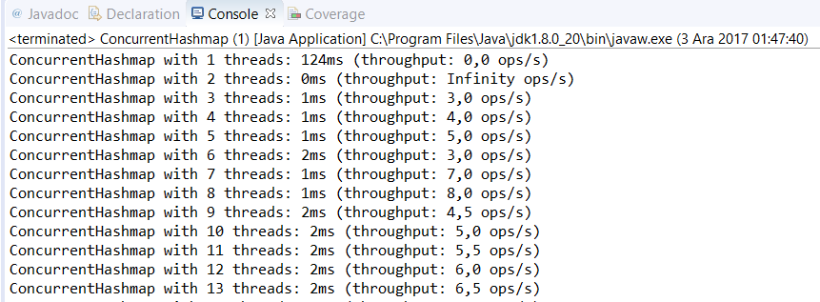

Conclusion
In this project, we implemented resizable concurrent hash table. The main aim was to understand and analyze the concurrent hash tables. ResizableConcurrentHashMap provides good performance and thread safety. Because, threads in the concurrent hash map can work on separate segments simultaneously instead of locking all map. Issues regarding ResizableConcurrentHashMap’s results were discussed in Performance Evaluation.

Glossary

References and Links
[1] Parminder Grewal , Sravanthi Tripuraneni. Concurrent Hashing.
http://cs.nyu.edu/~lerner/spring10/projects/Hashing
[2] Josh Triplett, Paul E. McKenney, Jonathan Walpole. Resizable, Scalable, Concurrent Hash Tables. https://www.pdx.edu/sites/www.pdx.edu.computer-science/files/tr1101.pdf
[3] Steven Feldman, Pierre LaBorde, and Damian Dechev. A Lock-Free Concurrent Hash Table Design for Effective InformationStorage and Retrieval on Large Data Sets. https://ll.mit.edu/HPEC/agendas/proc11/Day1/Posters/A-9_Feldman_A.pdf
[4] Arun Pandey. How ConcurrentHashMap Works Internally in Java
https://dzone.com/articles/how-concurrenthashmap-works-internally-in-java
[5] Richard Burnison, The Concurrency of ConcurrentHashMap, https://www.burnison.ca/articles/the-concurrency-of-concurrenthashmap

